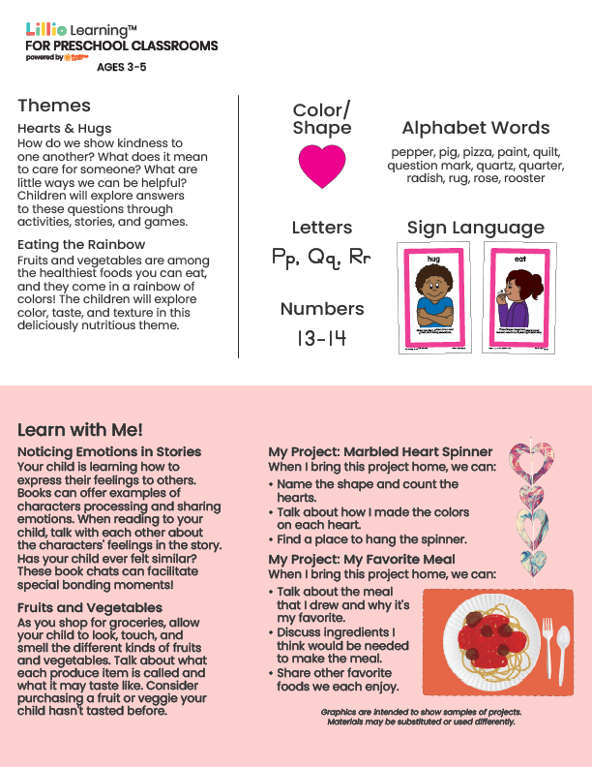
Add Your Name/Logo Here
February 2026
Newsletter



Add Notes

